

Master project HS Fulda Fall2016

**Single Project Specification**

**Group #1**

**12.01.2017**

**Team:**

Patrick Hasenauer

(<patrick.hasenauer@informatik.hs-fulda.de>)

Michelle Rothenbücher

Jonas Kleinkauf

Martin Herbener

Franz Weidmann

Plisam Ekpai-Laodema

~~Steffen Scholl~~

~~Ziad Benhachen~~

|  |  |
| --- | --- |
| Submission Version | Date |
| 1 | 12.01.2017 |

Fuldaflats.de implemented with   
ASP.NET Core

.NET based cross-platform API and website

1. **Executive Summary**

The main goal of my single project is to implement the current Fuldaflats.de API with the new ASP.NET Core framework from Microsoft. The secondary goal is to test the cross-platform ability from the ASP.NET Core framework.

“ASP.NET Core is a new open-source and cross-platform framework for building modern cloud based internet connected applications, such as web apps, IoT apps and mobile backends. ASP.NET Core apps can run on .NET Core or on the full .NET Framework. It was architected to provide an optimized development framework for apps that are deployed to the cloud or run on-premises. It consists of modular components with minimal overhead, so you retain flexibility while constructing your solutions. You can develop and run your ASP.NET Core apps cross-platform on Windows, Mac and Linux.“[1]

1. **Use Cases**

The defined use cases in the Fuldafalts.de milestone 2 and 3 document won’t be changed, because the implementation of the ASP.NET Core based API shouldn’t require to change the client user interface and logic.

All defined use cases in the Fuldafalts.de milestone 2 and 3 document should work after the new implementation.

1. **Data Definition and Database Structure**

The new ASP.NET Core based API should reuse the existing database to avoid migrating the current Fuldaflats.de data into a new database.

1. **Functional and Non-Functional Requirements**

The new Fuldaflats.de website with the new ASP.NET Core based API should fulfil the same functional and non-functional requirements as the current Fuldaflats.de website.

Some additional and secondary non-functional requirements are:

* The Fuldaflats.de website should run on a Linux operating system.
* The Fuldaflats.de website should run on a Windows operating system.
* The Fuldaflats.de website should run as an azure cloud app service.

1. **System Architecture**

The server-side framework and technology will be changed from node.js express to ASP.NET Core. This change requires some changes for the development and some changes in the architecture.

**Development**

For the development, I will use the Visual Studio 2016 from Microsoft instead of Visual Studio Code from Microsoft.

**Architecture**

As you can see in the old and new system overview graphic, the node.js and express will be replaced though the ASP.NET Core framework. For the MySQL database connection, I will use a ASP.NET Core extension which is provided form the MySQL company. The FuldaFlats.de JavaScript client and Html pages will be reused.

**Old** **System Overview Graphic**

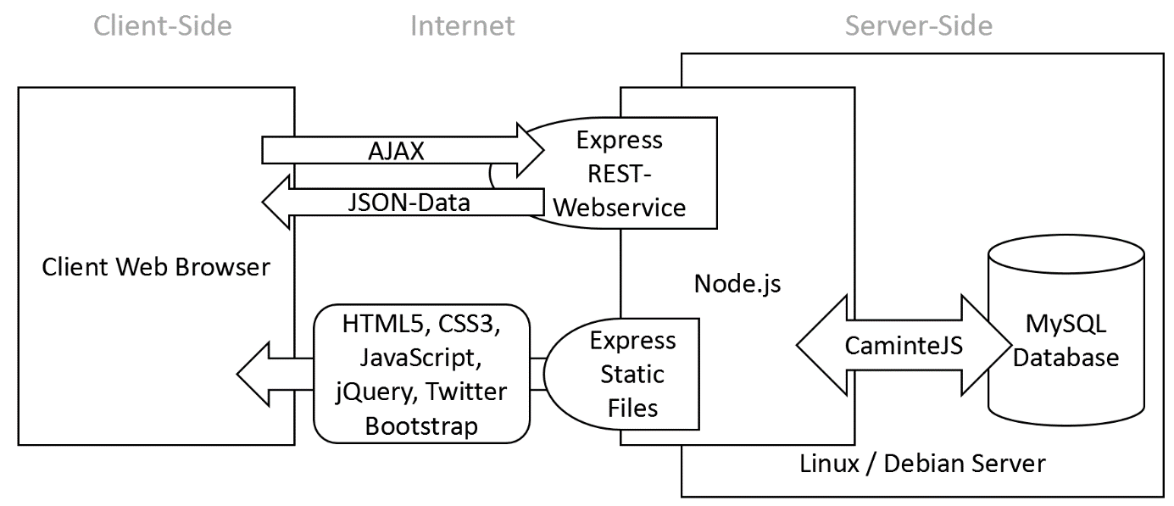

**New System Overview Graphic**

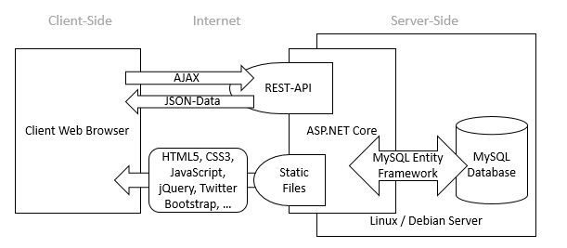

1. **High Level APIs**

The new ASP.NET Core based API should implement all APIs which are currently used from the Fuldaflats.de JavaScript client.

1. **Work Schedule**

|  |  |  |  |
| --- | --- | --- | --- |
| Day | Description | HOurs | |
| 1 | ASP.NET Core instruction   * Get to know the technology and framework * Probing possibilities | | 6 |
| 2 | Start ASP.NET Core project implementation for Linux   * Build base structure * Implementing a breakthrough | | 8 |
| 3 | Test the breakthrough for windows and for a cloud azure app service | | 6 |
| 4 | Implementing authentication | | 6 |
| 5 | Implementing API routes | | 8 |
| 6 | Implementing API routes | | 8 |
| 7 | Testing and fix bugs for Linux operating system, windows operating system and for an azure cloud service | | 8 |
| 8 | Testing and fix bugs for Linux operating system, windows operating system and for an azure cloud service | | 8 |
|  | **Total Hours** | | **58** |

1. **Team**

|  |  |
| --- | --- |
| **Name** | **Initial Role** |
| Patrick Hasenauer | Researcher, administrator, developer and tester |

1. https://docs.microsoft.com/en-us/aspnet/core/